David Zhu DataViz Week 12

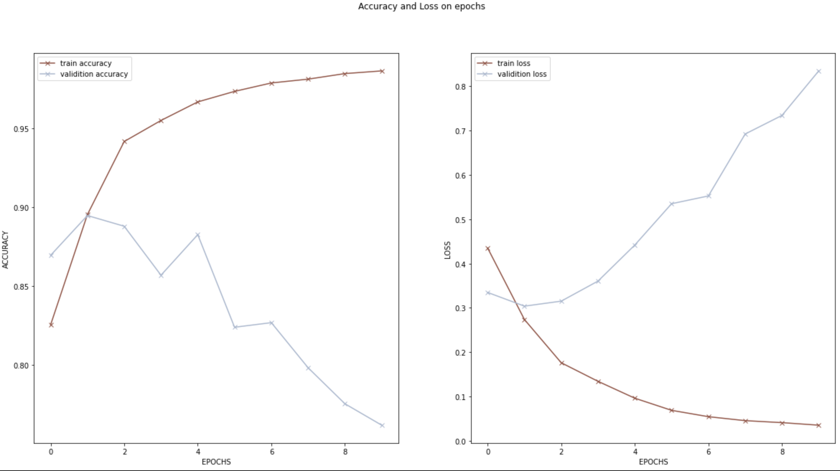

This visualization is from one of my other machine learning class. This plot is the relationship between the epochs of the model and its train, valediction accuracy and loss. This is good for its informative style that we can see the trends of it. But I think the color are a bit similar to each other, and the color indicator may be counterintuitive.